Shri Vaishnav Vidyapeeth Vishwavidyalaya ,Indore
Shri Vaishnav Institute Of Information Technology



Project Title:- Student Pass/Fail Prediction Using IBM SPSS Modeler

Submitted To:- Submitted By:-
Abhishek Singh Pratha Solanki
Anshika Nigam
PROJECT REPORT
1. Abstract
This project focuses on predicting whether a student will pass or fail using data mining techniques. By analyzing factors such as marks, attendance, and study hours, a predictive model is built using IBM SPSS Modeler. The model helps identify students at risk and improves academic decision-making.
2. Introduction
In today’s educational system, analyzing student performance is important for improving results. Predicting student outcomes helps teachers take necessary actions early. This project uses SPSS Modeler to apply classification techniques and generate predictions based on historical student data.
3. Objective
- To predict student performance (Pass/Fail)
- To apply classification algorithms
- To analyze important factors affecting results
- To visualize results using graphs
4. Problem Statement
Educational institutions face difficulty in identifying weak students early. This project aims to develop a system that predicts student performance and helps improve overall academic success.
5. Tools & Technologies
- IBM SPSS Modeler
- Data Mining Techniques
- Classification Algorithms (C5.0, Logistic Regression)
6. Dataset Description
The dataset contains student-related attributes such as:
- Student ID
- Marks
- Attendance
- Study Hours
- Assignment
- Final Result (Pass/Fail)
7. Methodology
7.1 Data Collection
Data is collected from student academic records.
7.2 Data Preprocessing
- Missing values handled using Filler Node
- Data transformed using Reclassify Node
- Data balanced using Balance Node
7.3 Data Partitioning
- Dataset divided into:
  - Training Set
  - Testing Set
(using Partition Node)
7.4 Model Building
- Applied classification models:
  - C5.0 Decision Tree
  - Logistic Regression
7.5 Model Evaluation
- Accuracy
- Confusion Matrix
7.6 Result Visualization
- Table Node
8. System Workflow
Data Source → Reclassify → Filler → Balance → Partition → Model → Result → Graph → Table
9. Results & Discussion
- The model successfully predicts student performance.
- Accuracy depends on input data quality.
- Graphs such as ROC curve and bar charts help visualize performance.
10. Advantages
- Early identification of weak students
- Improves academic planning
- Easy to use and implement
11. Limitations
- Depends on dataset quality
- Limited features reduce accuracy
- Not suitable for very large datasets
12. Future Scope
- Implementation using Python (Machine Learning)
- Integration with school systems
- Use of advanced algorithms
13. Conclusion
The project demonstrates how data mining techniques can be used to predict student performance. It helps in identifying students who need support and improves overall academic outcomes.
16. Screenshots
SPSS Modeler Stream:-
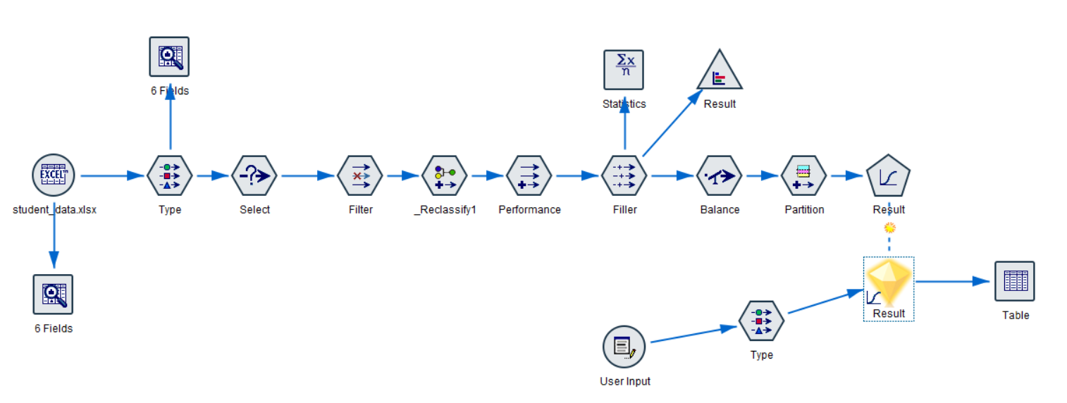
Result Table:-
